

**525 McClurg Road**

**Youngstown, OH 44512**

**Phone: (330) 427-3000**

**Email:** [**info@transformercomponents.com**](mailto:info@transformercomponents.com)

**Website:** [**www.transformercomponents.com**](http://www.transformercomponents.com)



**TRANSFORMER RADIATOR VALVE   
RFQ FORM**

**CUSTOMER INFO:**

**NAME:** __________________ **COMPANY NAME**: ________________________

**PHONE NO.:** ______________ **EMAIL:** ________________________________

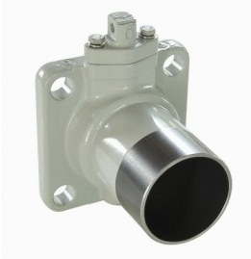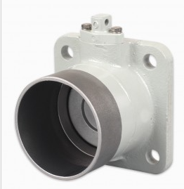

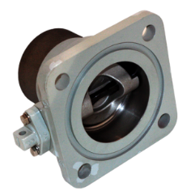 **Radiator Weld - on**

**Valve Type: Weld-on QTY _____ When Needed: _________**

1. **Valve size** (Disc Size):3” ____ 4” ____
2. **Header Pipe Diameter:** 3” ___ 4” ____ 5” (only for SS 4” valves) _____
3. **Header Pipe Length:** (4” to 15”) ________
4. **Valve Material:** Carbon Steel ___, 316 Stainless___,
5. **Disc & shaft Seal:** H-NBR (-50 to +120 ºC) _____ VITON (-40 to +130º C) ______
6. **O-ring (Flange Seal):** H-NBR- MS (-50 to +120 ºC) _____ VITON (-40 to +130º C) ______

Fluor-silicone(-60 to +200º C) _____

1. **Valve:** Assembled ___ Disassembled ____

*(Bolt Circle Pattern = for 3” Valve F = 160 mm for 4” Valve F = 192 mm)

*(Bolt Holes size F 22mm (7/8”))

**Radiator Rectangular Wafer.**

[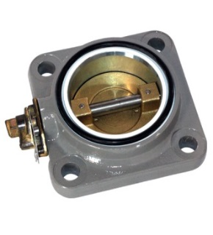](http://www.zenithgroupusa.com/images/product-3.png)

**Valve Type: Rectangular Wafer QTY _____ When Needed: __________**

1. **Valve size** (Disc Size):3” ____ 4” ____
2. **Bolt holes size:** F 19mm(7/8”) ___, F 22mm (7/8”) ____,
3. **Valve Material:** Carbon Steel ___, 316 Stainless___,
4. **Disc & shaft Seal:** H-NBR (-50 to +120 ºC) _____ VITON (-40 to +130º C) ______
5. **O-ring (Flange Seal):** H-NBR- MS (-50 to +120 ºC) _____   
   VITON (-40 to +130º C) ______ Fluor-silicone(-60 to +200º C) _____
6. **Valve:** Assembled ___ Disassembled ____

*(Bolt Circle Pattern = for 3” Valve F = 160 mm for 4” Valve F = 192 mm)

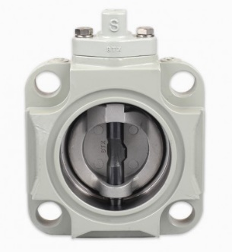

**Radiator Round Wafer**

**Valve Type: Round Wafer QTY _____ When Needed: __________**

1. **Valve size** (Disc Size):3” ___/ 4” ___/ 6" _____/ 8"______/ 10"_______/ 12"_______
2. **Bolt Circle Pattern** F = 150mm/ 200mm/ 250mm/ 300mm
3. **No of holes:** 6 holes/8 holes/ 8 holes/ 8 holes/ 8 holes.
4. **Stud-bolt size:** 8 holes/ 8 holes/ 8 holes/ 8 holes.
5. **Bolt holes size:**  various sizes
6. **Valve Material:** Cast Iron Body ___,
7. **Disc & shaft Seal:** H-NBR (-50 to +120 ºC) _____ VITON (-40 to +130º C) ______
8. **O-ring (Flange Seal):** H-NBR- MS (-50 to +120 ºC) _____ VITON (-40 to +130º C) ______

*(Dimensions changeable as requirements dictate)

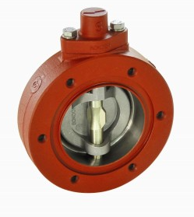

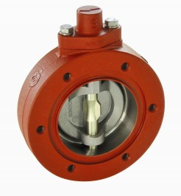

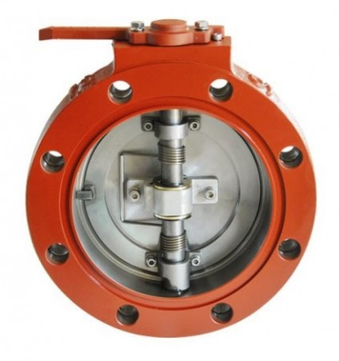

**Double Flange Radiator Valve**

**Valve Type: Double flange Radiator QTY _____ When Needed: __________**

* **Application:** Power Transformer Replacement valve for Beck Power transformer **.**

1. **Valve size** (Disc Size): 4” ___/ 6" _____/ 8"_____**.**
2. **Valve Material:** - Cast Iron Body ___**,**
3. **Bolt Circle Pattern** ANSI bolt circle F = 150mm/ 200mm/ 250mm/ 300mm
4. **No of holes/holes size:**  **:** 6 holes/8 holes/ 8 holes/ 8 holes/ 8 holes. Size 22mm
5. **Disc & shaft Seal:** NBR (-50 to +120 ºC) _____
6. **Paint:** - ANSI 70 Gray Painted

[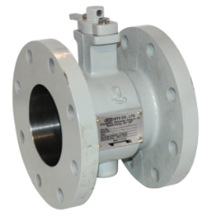](http://www.zenithgroupusa.com/images/product-5.png)

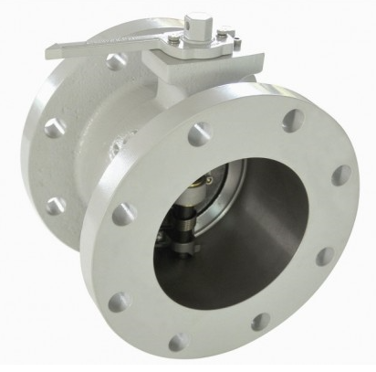

**For further information on this product and others from Specialty Transformer Components please visit our website at** [**www.transformercomponents.com**](http://www.transformercomponents.com)**.**